## Chapter 4 Experiment 3 Display devices Interfacing

In Chapter 4 we will practicing how to make use of 8254 PIT controller. And moreover, move a little bit forward, program and debug a small complicated program to display something with six nixie tubes.

## Assignments

1. Frequency division practicing .

In this experiment, a crystal oscillator of 500kHz is used as the clock source of a piece 8253 PIT controller, as shown in Figure4.1 the circuit schema. And there are 3 led lights are connected to the signal out pins of the 8253. You are required to write a short initialization program to setup the 8253, so that to twinkle one of the led in a frequency of 0.5Hz, and the led should be light for nearly 1s, and be off for another 1s. A template is provide for the program in 8253Div.asm, as is shown in text box below.

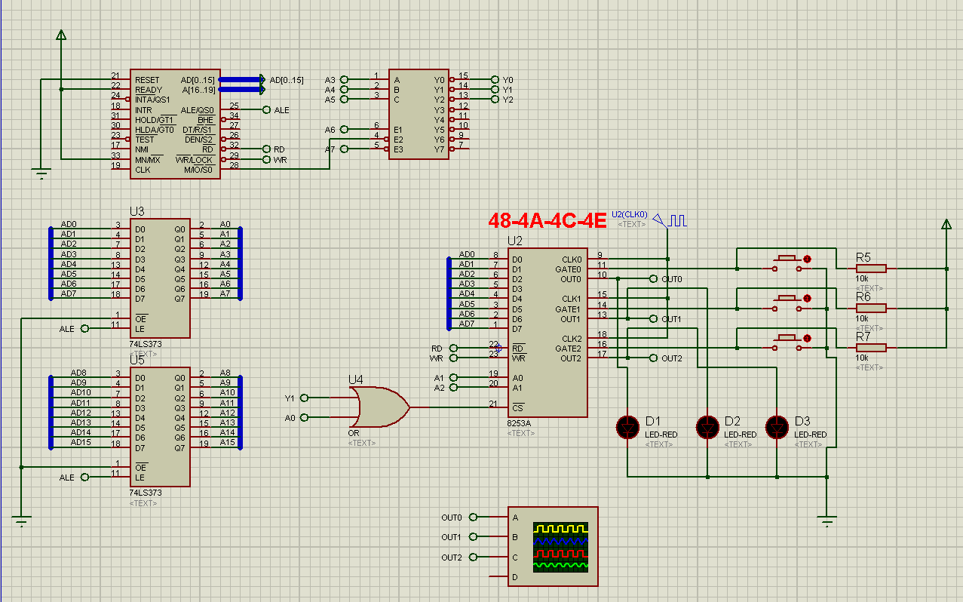

Figure4.1 Circuit schema of assignment1

;========================================================

;Description: Program of Assignment 3 Experiment1

;Author:[name][student ID]

;Date:[Date]

;========================================================

;view 8254 output

;LED1 displays out0 of timer0

;LED2 displays out1 of timer1, and LED1 should light for 1s and off for 1s

.MODEL SMALL

.STACK 32

.DATA

IOS4 EQU 048H;

.CODE

MAIN PROC FAR

;TODO1: program timer0, both cmd and initial value

;TODO1: program timer1, both cmd and initial value

MOV AX, 4C00H

INT 21H

MAIN ENDP

END MAIN

1. Digital tube display control.

In this experiment, a digital tube constructed by 6 nixie tubes are provided as a display, as shown in figure4.2. These six nixie tubes share a group of common inputs: pinA, B, C,...P,...U,DP. By providing a high voltage at these pins, the display fields of all the tubes will be turned on. Thus if we want to display only one digit number, we should active only one tube but not all of them before we send pattern_code to the common input pins. The tube selective pins are on the right side: pin1,2,...5. By providing a GND voltage to one of the selective pins, and high voltage to others, we can active only one nixie tube for display. In the digital tube display in Figure4.2, pin1 will active the tube on the leading left side, and pin6 will active the tube on the most right side. As a result, if you want to display 6 digits, you should active tube1 in the first place, and output pattern_code of the first digit to the digital tube display, then turn off tube1, and turn on tube2, output the pattern_code of the second digit. And so on till you display the sixth digit. Then roll back to display the first digit with tube1, and repeat continuously.

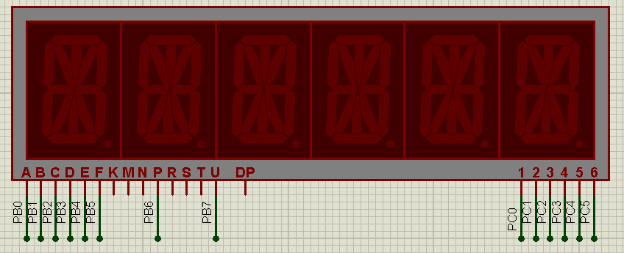

Figure4.2 Digital tube display

In the hardware schematic design of assignment2 (figure4.3), the digital tube display is connected to the ports of a piece of 8255. PortB is used to send pattern_code, and PortC is used to send tube-active-code.

There is a variable DATA1 defined in the DATA segment. It contains 6 digits and is stored in the DATA segment in unpacked BCD format. Please write a program and display DATA1 with the digital tube display. A template of the program is provided in file 8255Tube.asm. And port numbers and pattern_codes table are defined in the template code file.

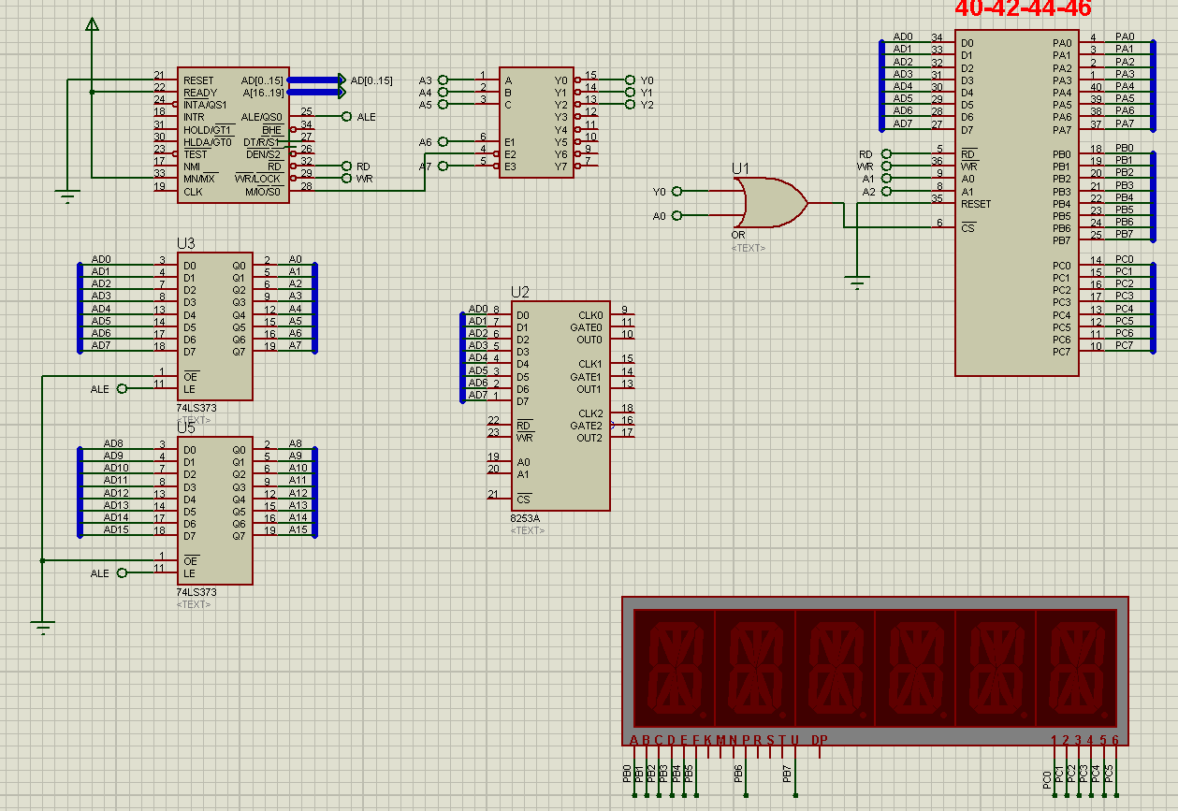

Figure4.2 Circuit schema of assignement2

## Experiment Preparation

All the thing below should be prepared for experiment1:

1. The programs for assignment 1 and 2;
2. The VMWare Virtual Machine Windows XP with Emu8086 and Proteus installed.
3. Import hardware schematic design files into Windows XP virtual machine.

## Experiment Circuit Scheme

See figure 4.1 and figure 4.2.

## Experiment Process

Start the the virtual machine Windows XP, and import all the programs of assignments.

Debug the program till it runs properly.